iR  Fact sheet  Developers:  Imaginary Root Studio LLC  Punchline Gaming LLC  Location  Pittsburgh, USA  Website:  https://www.squared-game.com/  Press/Business Contact:  wpb@imaginaryrootstudio.com  Social:  twitter.com/irootstudio  https://twitter.com/GamingPunchline | Squared 2  an Ios game  Description  Squared 2 is a game that challenges your dexterity as you steer the player square around the screen, avoiding enemy squares and picking up power-ups. With increasing difficulty and challenging enemies, your skill will be tested as you try to see how long you can last.  Green power-ups help you recover from damage taken by running into red squares. The game ends once you take two hits in a row, so be sure to look out for these! Yellow power-ups clear the entire screen of enemy squares, so be on the lookout to grab one when you need to get out of a tight jam.  Colliding with red squares damages you, so do your best to avoid them. Most squares move slowly, but be on the lookout for squares that can move in other ways. You may encounter spinning squares, dashing squares, pausing squares, and potentially others.  Each survival run lasts a few minutes, which makes Squared 2 perfect for quick gaming sessions while you are on the go.  contact  For general information about the Studio and its games and app, please contact us at the following:  irootstudio on Twitter  Punchline Gaming on twitter  wpb@imaginaryrootstudio.com  Images  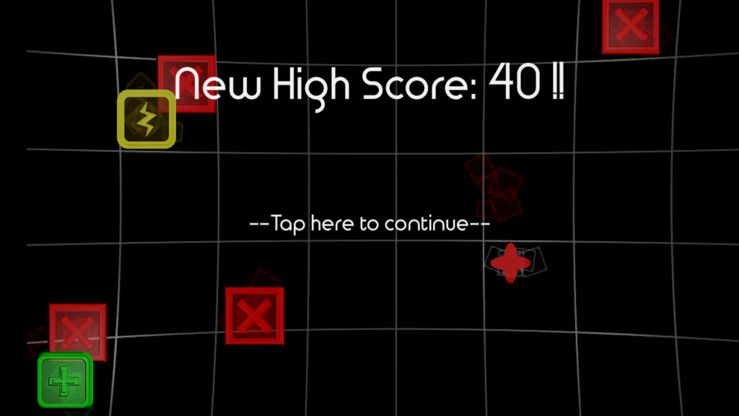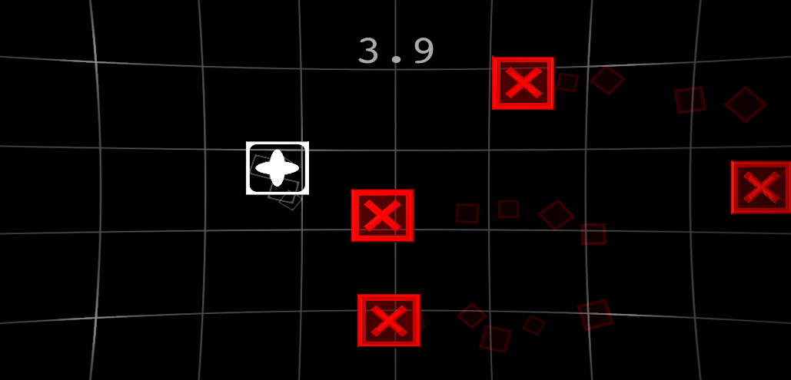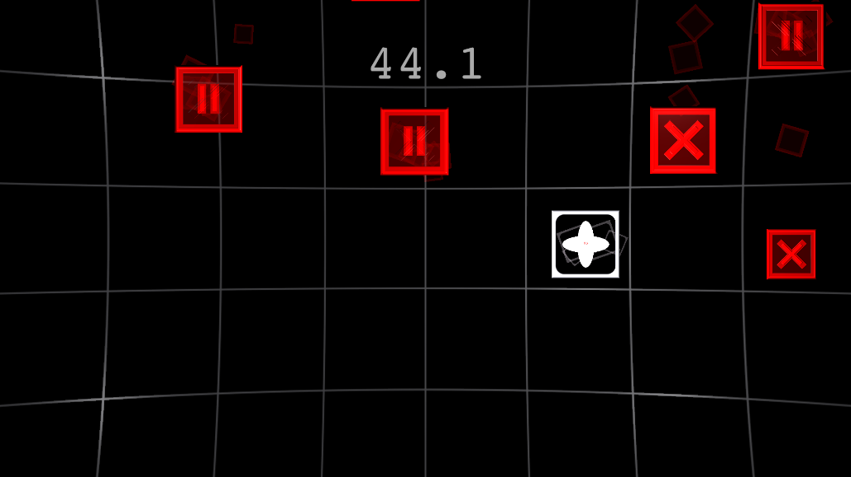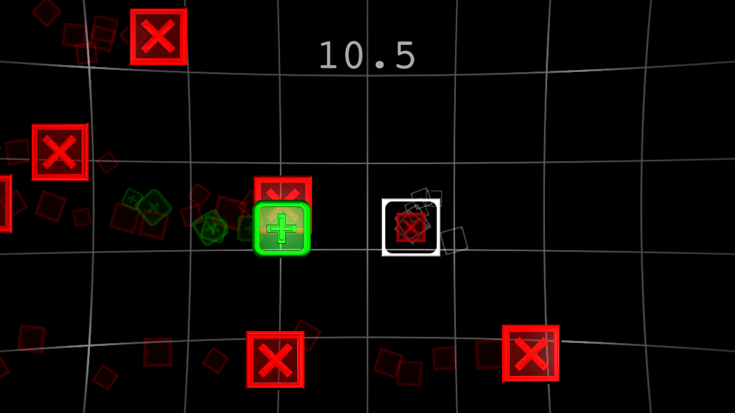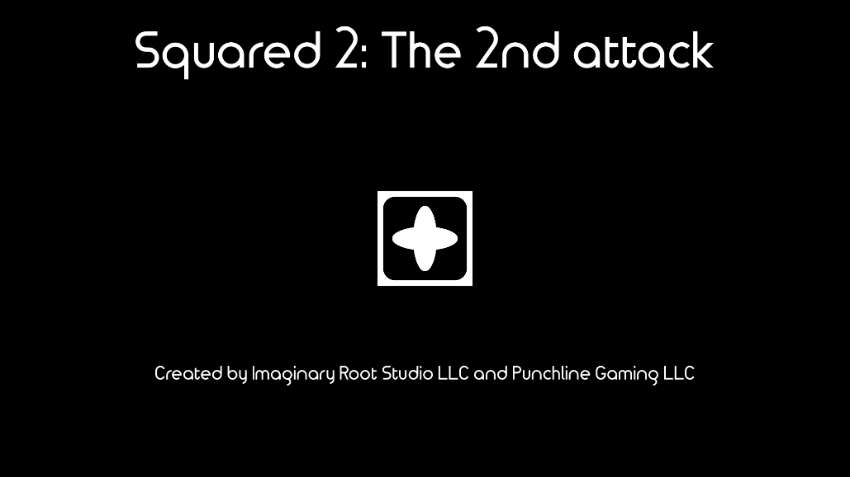  For reviewer Game Codes  Please provide press credentials to Support to gain access code, additional information, and to schedule interviews.

